When I go from this screen, having selected Scratch 2
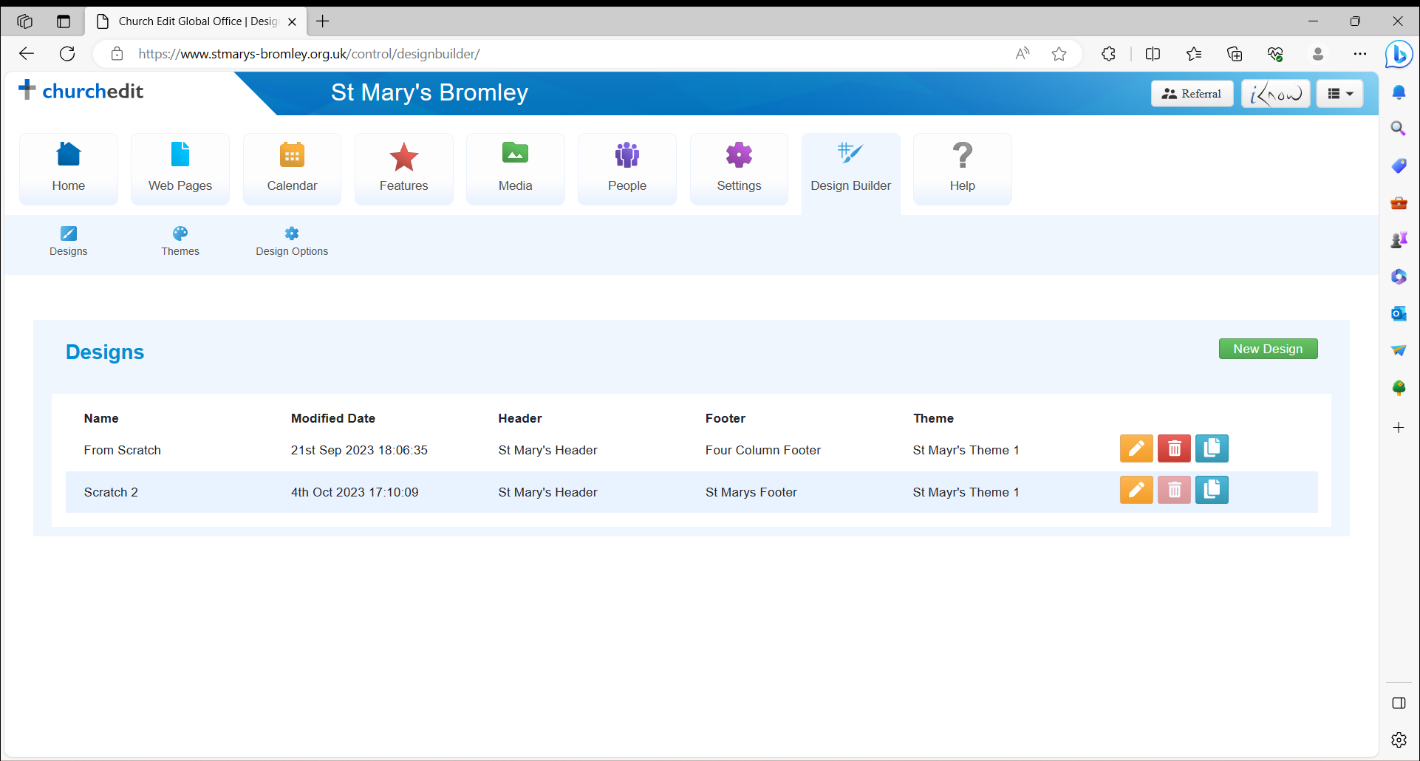
I get:

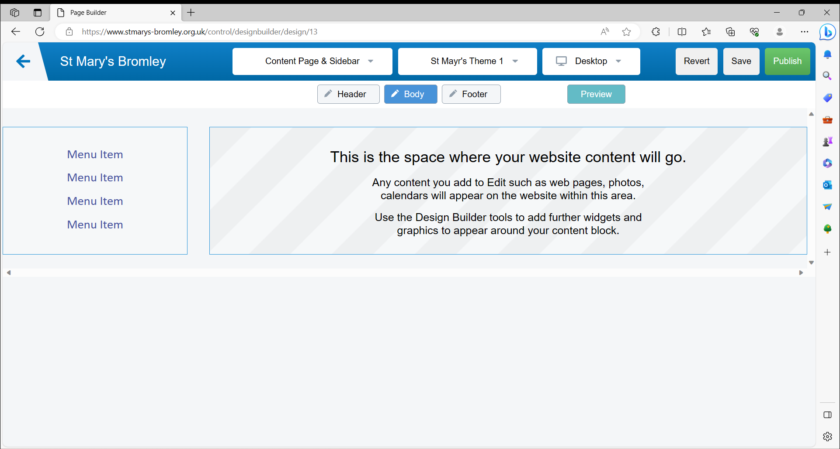
Scratch 2 is the design being used on the St Mary’s Bromley website
